**Example**: You are given the following training examples. Each example has only one attribute, and the classification into positive / negative

|  |  |  |
| --- | --- | --- |
| *Index* | *X* | *Label* |
| *1* | *1.0* | *Positive* |
| *2* | *2.0* | *Negative* |
| *3* | *4.0* | *Positive* |
| *4* | *5.0* | *Positive* |
| *5* | *6.0* | *Negative* |
| *6* | *7.0* | *Negative* |

Your main task is to evaluate the following algorithm that use a set *S* of training examples to classify the example with attribute value of *x*

Algorithm:

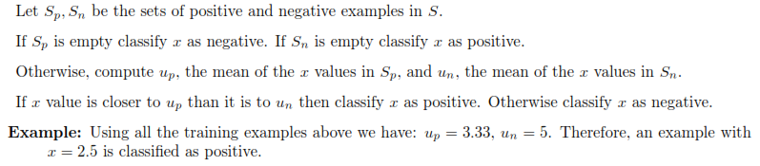

1. Use leave-one-out cross validation to estimate the errors of Algorithm above
2. Use 3 Fold CV to estimate the errors of Algorithm above. Run cross-validation using following permutations of the data (1, 3, 4, 2 ,5 ,6)